# Chapter 6 Physics of MOS Transistors

# 6.2. Operation of MOSFET

 (9)

 (10)



 (35)

 (44)

 (45)

 (46)

 (47)

# 6.3. MOS Device Models

 (65)

# 6.4. PMOS Transistor

 (69)

 (70)

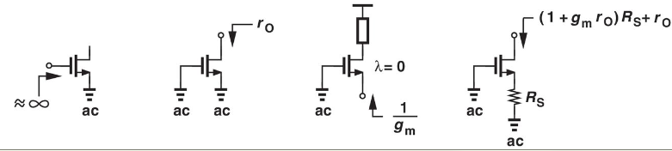

# 10.3. MOS Differential Pair

Under Equilibrium Conditions:

 (104)

 (105)

 (106)

 (107)

Differential Pair Gain:

 (117)

 (142)

 (146)

# 11.2. High-Frequency Models of Transistors

Transit Frequency:

 (49)

Direct Analysis Model For a CS stage:

 (70)

 (71)

 (72)

Input Impedance for a CS stage:

 (92)

# 11.6. Frequency Response of Followers

 (109)

 (110)

 (111)